Renju lesson on November 29, 2001
Hello everyone! Welcome to Online Renju Class.
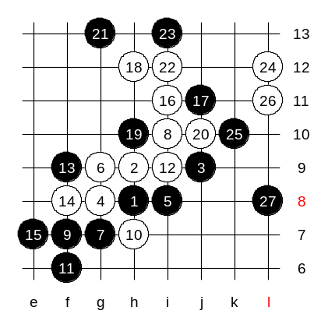
How many of you analysed the problematic d5 variant during past week? Some of you did. First we can take a look at jahre’s suggestion. Jahre in his quick analysis suggests 25-k10 and 27-L8. It is our teamwork to check whether the white can win or not.
And since most of you suggest 25-k12, we will check it as next.
Where is white win in Jahre’s variant? Put your brains into action. ☺

I am waiting your suggestions for the next white move. Please type it here as soon as you find one.
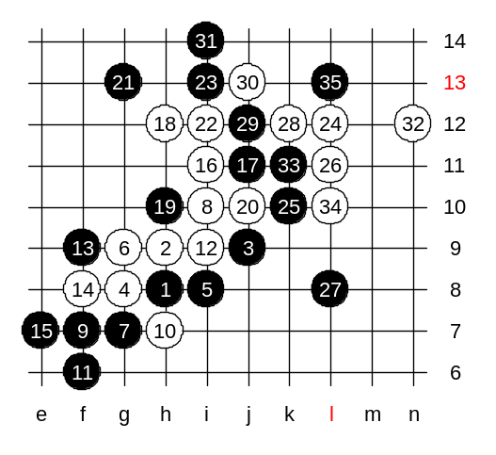
His analysis is based on controls at L10 and h11.
He analysed only few moves. So, we need check the others. In my opinion, no matter if 32-n12, 32-m12, or 32-m11, black can use same block k11.

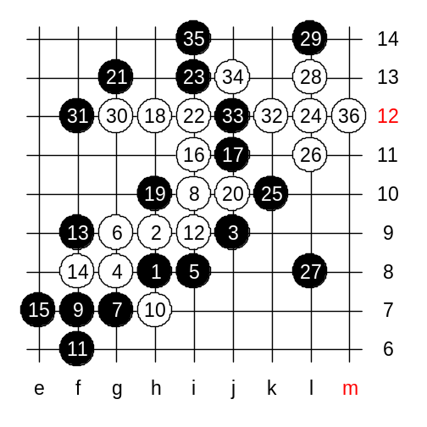

Now we try another sequence of white attack. Suggested by yyfcsd. White wins.
If 31 to other side then 3x3 or even overline.

This variant turned out to be white win, so we change to k12.

Now we try 25-k12.

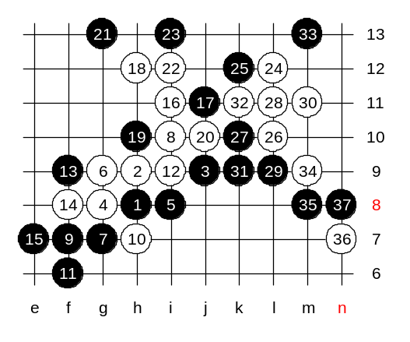
Yes, now we reach to the position where I once mentioned that white seems to have an idea but no sequence. Lets seek for white win now.
We try one example sequence and see the problem.

Black must defend carefully. Yes, m8 point was forced. It was white’s last trap. Now white has failed attack.
We can close the variant here.

We can try one more idea, it was Bensonla’s suggestion last week after class. We discussed it without making moves, so the outcome was not clear.

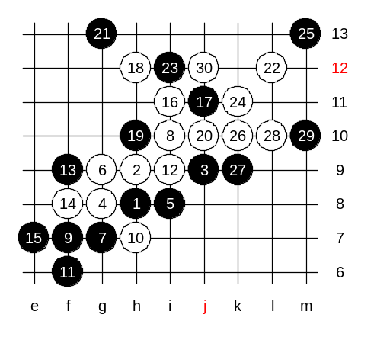
Now, this position after the 30th move reminds me about the old d3 homework. Do you remember it? It is not exactly the same here, some differences though, therefore we will have to check all over again. I have a suggestion. Since this variant needs deeper look, lets give ourselves a week of time, and try to get more familiar with this situation within a week, and next Thursday we can continue the analysis here.

Before we will look at the other 5th move, we need to check the safe variant, too.
It is a backup variant in case we are not sure of that sharp variant we studied just before.
15-i11. I let you vote for the next white move.
We will play 16-g11. Active style. Which black move is good.
Do you know why 17-h10 is better than 17-g10? Well, here is a tactical issue involved. Let me explain. Do you remember, long time ago when we learned d3, I told you about two-side attacking method where black tries to activate two sides and lets white choose one to defend.
Well, think about it. Black left side is powerful. You all agree white must defend there anyway, right? So the g10 stone is pretty useless after that, right?
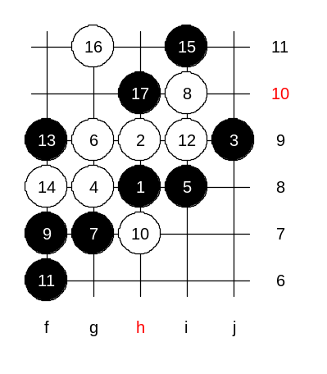
And, if we imagine having black stone at g10, and white blocks on left, then we can see the weakened upper side and plus white has an active and disturbing pair.
If we choose h10 instead of g10, then we strengthen our left and upper side. Besides, white has one g-line left, but it is useless because it is too far to bother black’s right side activity.
Now, after h10, black still keeps the left and right side power, and white’s g-line is totally useless.

